USDN Phoenix Project Final Report

**Program design**

In the first quarter of 2023, Solar United Neighbors (SUN) coordinated with City of Phoenix staff to design a program that would help 10 low-income Phoenix households install solar panels at no cost to them, called the Phoenix Solar Energy Assistance Program (PSEAP). The City of Phoenix received $225,000 to devote to this project, which SUN determined would be enough to cover the cost of ten 6kW rooftop solar systems, with enough funds to be able to pay for minor roof/electrical repairs, extended warranties on equipment, extended labor warranties, reporting and tracking of the solar once installed, and SUN’s staff time. The program was designed so that each homeowner would not be responsible for paying anything out of pocket, even if something went wrong with the system years down the road.

In consultation with the City of Phoenix, SUN determined the eligibility for this grant program which required applicants to:

* Be a resident of Phoenix who owns their home (with roof in good condition)
* Live in a Justice 40 census tract identified as “overburdened”
* Have a household income of no more than 200% of the federal poverty level (FPL)
* An Arizona Public Service (APS) customer, due to more favorable rooftop solar rates

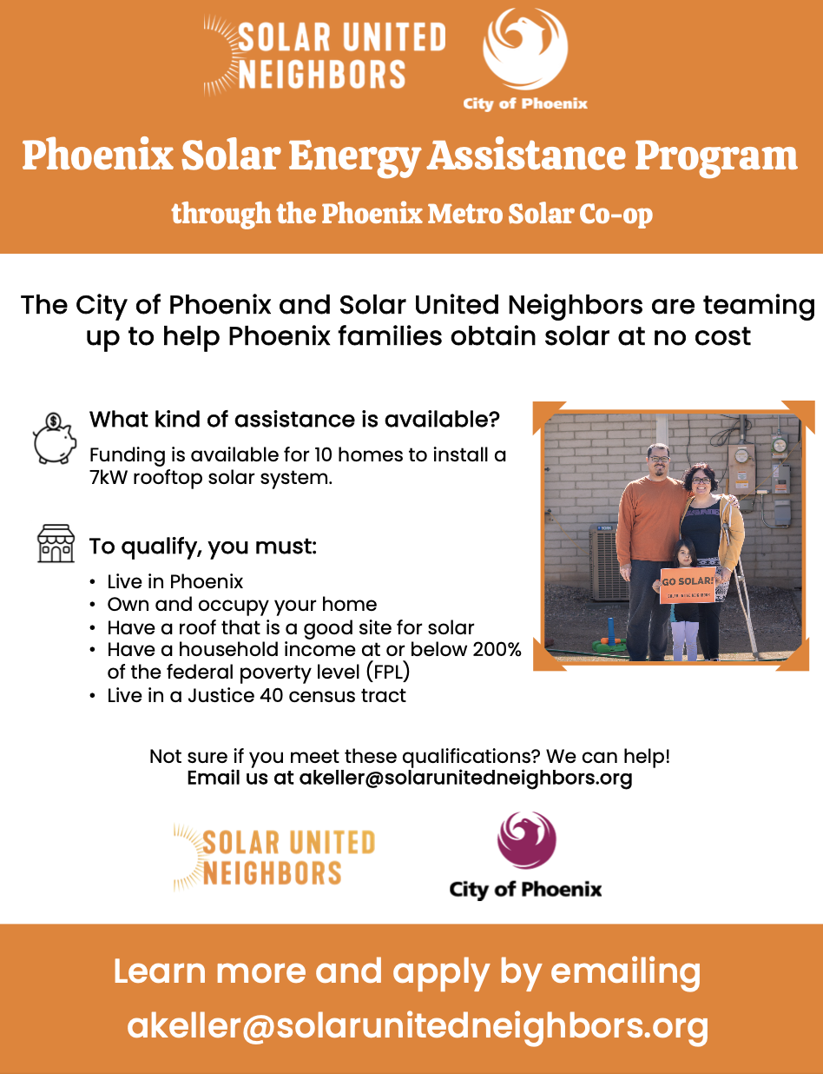

Flier for the Phoenix Solar Energy Assistance Program

City of Phoenix Human Services staff would be responsible for verifying the income of each participant, while SUN would be responsible for verifying the other eligibility requirements. SUN designed PSEAP to run in conjunction with our 2023 Phoenix Metro Solar Co-op, a group-purchasing campaign that enables multiple households (usually around 150) to install solar panels together through one competitively selected installer. Running the low-income program in conjunction with the market-rate co-op allows us to help even more low-income families afford solar, as the bulk purchase discount allows us to stretch the grant dollars further. Households interested in receiving a fully funded solar system as part of this project were instructed to sign up for the Phoenix Metro Solar Co-op and indicate if they are interested in and believe they qualify for the funding to cover their installation. After verifying eligibility, SUN would identify the final 10 households to be selected to receive funding.

The Phoenix Metro Solar Co-op launched on April 2nd in partnership with the City of Phoenix, City of Scottsdale Green Building Fund, Vote Solar, Raza Development Fund, and Chispa AZ.

**Participant recruitment**

As soon as the co-op launched, SUN and our partners immediately began recruiting market-rate households to join the co-op as well as low-income households who might qualify for the PSEAP. SUN organized three Solar 101 events which educated participants about the basics of solar and also included information about the Phoenix Solar Energy Assistance Program. Two of the Solar 101s were accessible to both English and Spanish speakers.

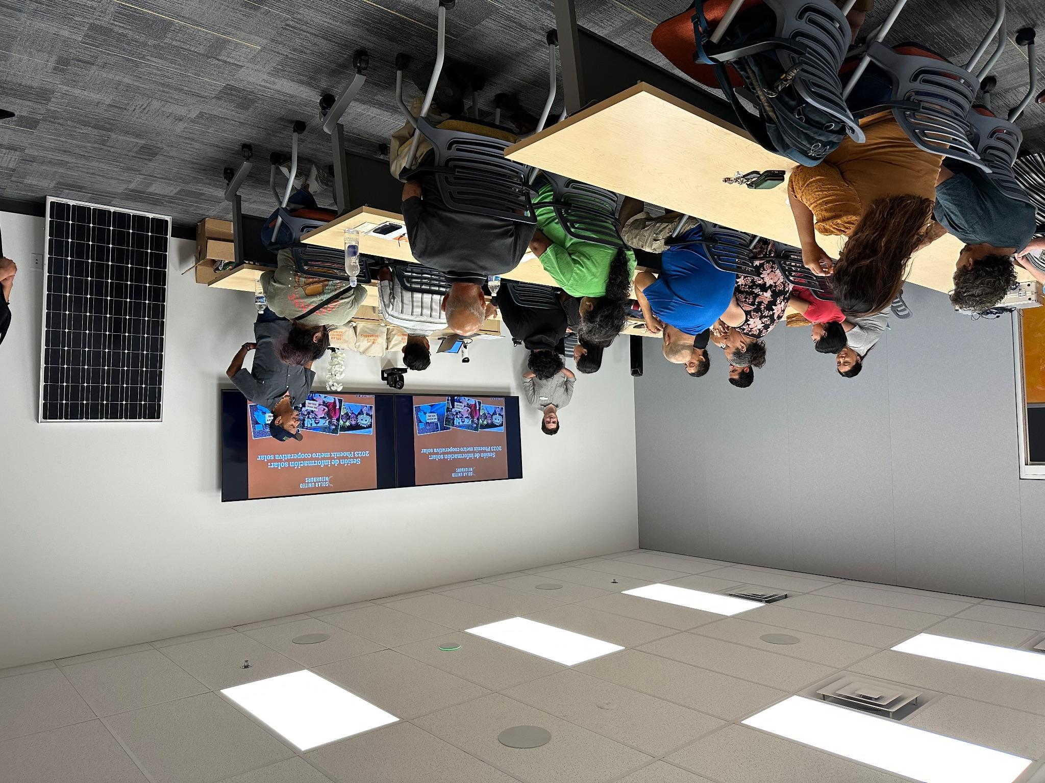

*Spanish Solar 101 Event in South Phoenix, hosted by SUN*

Recruitment for PSEAP applicants was slow and we quickly found out that our program requirements would make it difficult to find 10 households, particularly the requirement that they be APS customers. Two of the underserved neighborhoods within Phoenix we especially wanted to target were Maryvale in West Phoenix and the South Phoenix area, but the vast majority of these areas are served by the utility SRP. Based on feedback from attendees at our Solar 101 events, we recommended changing the program requirements to allow SRP customers to apply. This change, in addition to our partnerships with local community organizations, led us to eventually find ten qualifying households, but it was more difficult than we anticipated.

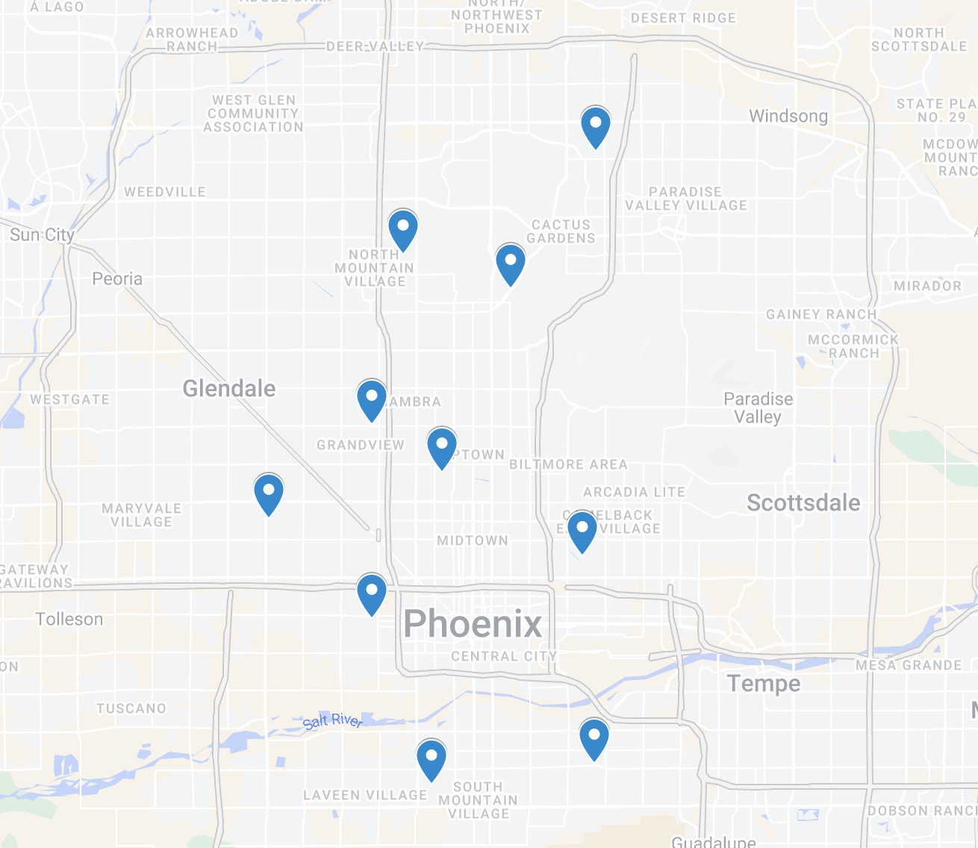

*Map of 10 low-income Phoenix solar applicants*

**Installer selection**

In June, members of the Phoenix Metro Solar Co-op met to review bids from solar installers and to select one installer to serve the co-op. Sunny Energy was selected by the group and they were eager to support the Phoenix Solar Energy Assistance Program. Because Sunny Energy’s bid was so competitive, we were able to fund 6.935kW systems as opposed to 6kW as initially budgeted, enabling us to fund even larger solar systems. SUN communicated the details of the PSEAP participants' installation with Sunny Energy, who coordinated directly with each participant to design and install a solar system. All payments were made directly by SUN to Sunny Energy on the participant’s behalf.

**Installation process**

As of January 31, 2024, ten participants have been accepted to receive funding from PSEAP and all have signed contracts with Sunny Energy to begin work on their homes. Six of those solar systems have been installed successfully, while the other four are in the pipeline and should be completed in the coming months. Some projects were completed faster than others because some homes needed a service panel upgrade (which was included in the grant) while others needed electrical or roofing work before installation could take place. SUN has regular check-ins with Sunny Energy and are monitoring the progress of each of the remaining participants’ projects.

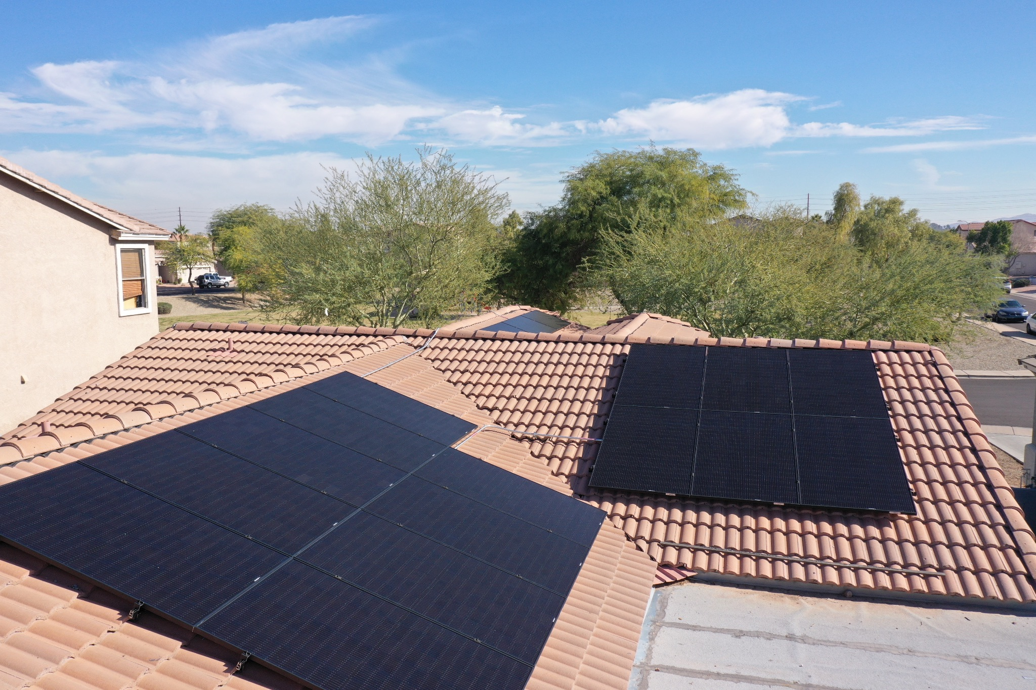

One of our PSEAP participant’s new solar system right after installation

**Storytelling**

SUN is coordinating with USDN and the City of Phoenix to hire a local videographer to tell the stories of some of the PSEAP participants. That recruiting process is ongoing, but we look forward to producing a high-quality video that illustrates the success of this grant program but also the success of rooftop solar for low-income households more broadly.

Arizona Program Director Adrian Keller has met with several of the participants in person. One, Sondra C., said that she and her husband had been wanting to install solar for a long time after seeing how much their neighbors enjoyed it. But the upfront financial cost was always too high a barrier to cross. Now, thanks to this program, they are producing their own energy from the Arizona sunshine. Another participant, Laura C., told us how excited she was to see her first month of electric bills after going solar and that the financial savings was a big relief to her family’s budget. We look forward to continuing these conversations and sharing additional details as the final installations wrap up.

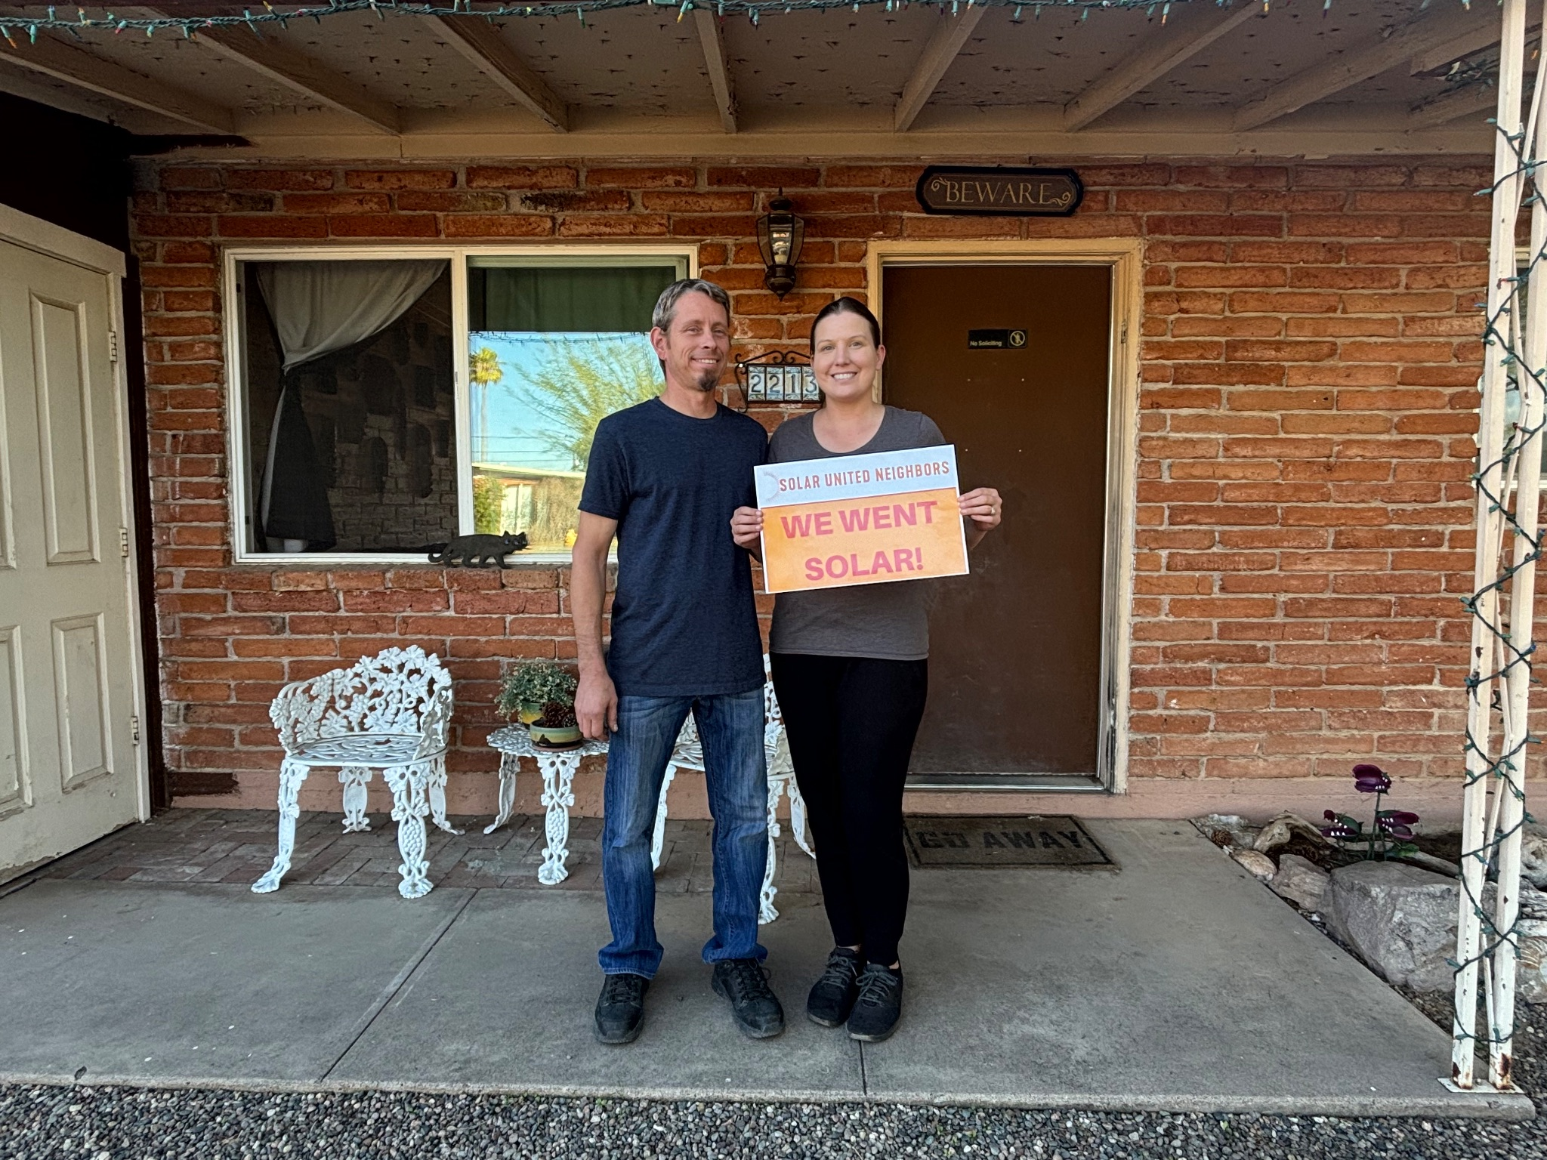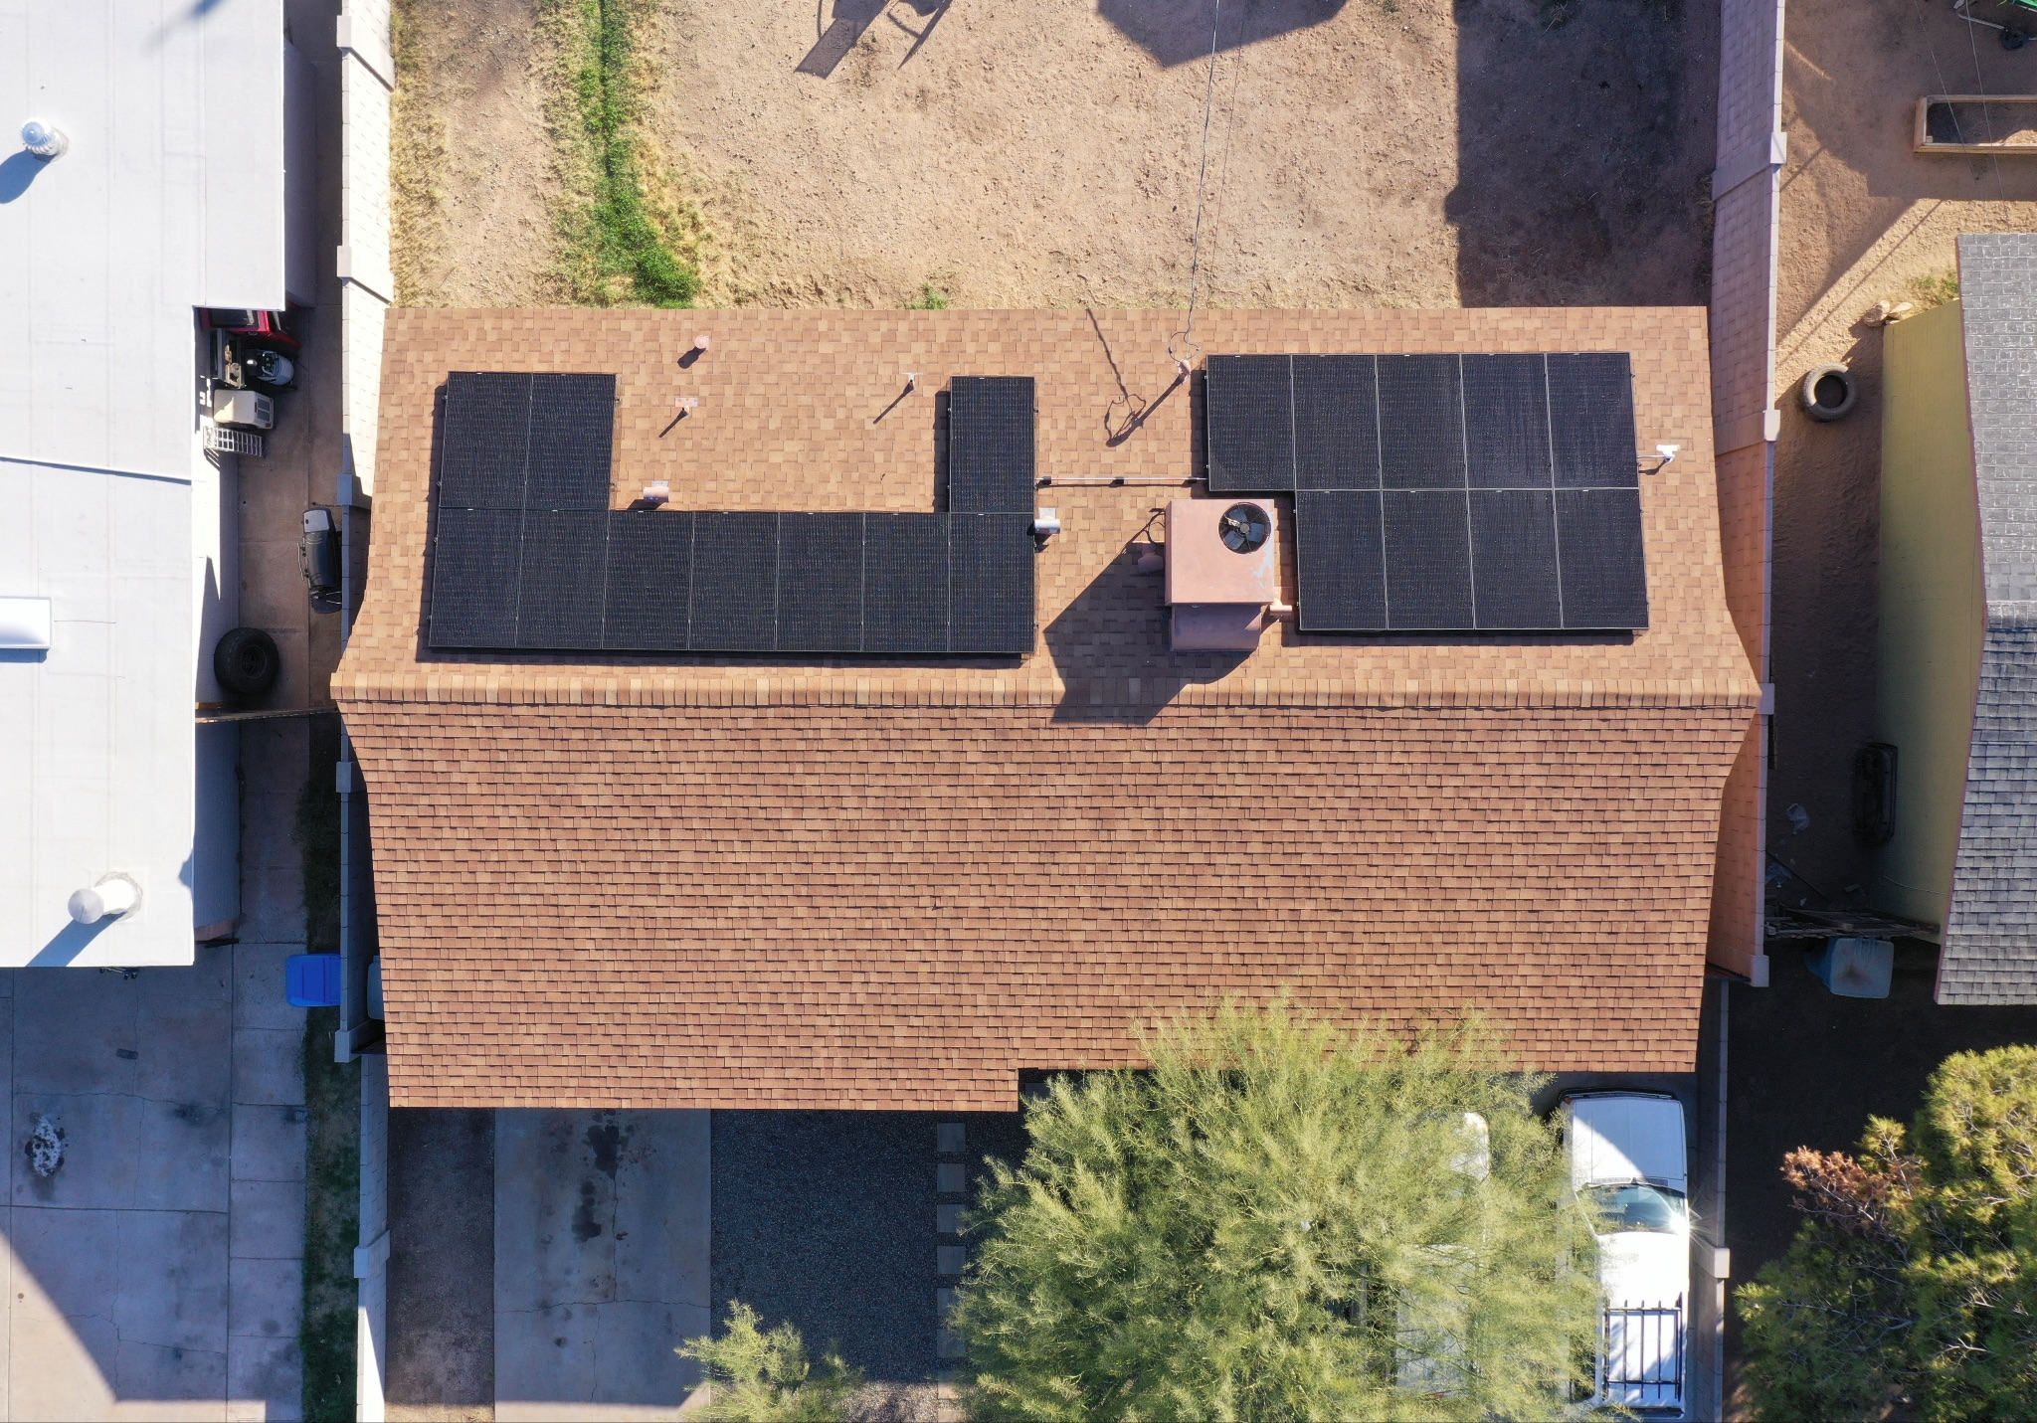

Sondra and her husband and their new solar system!

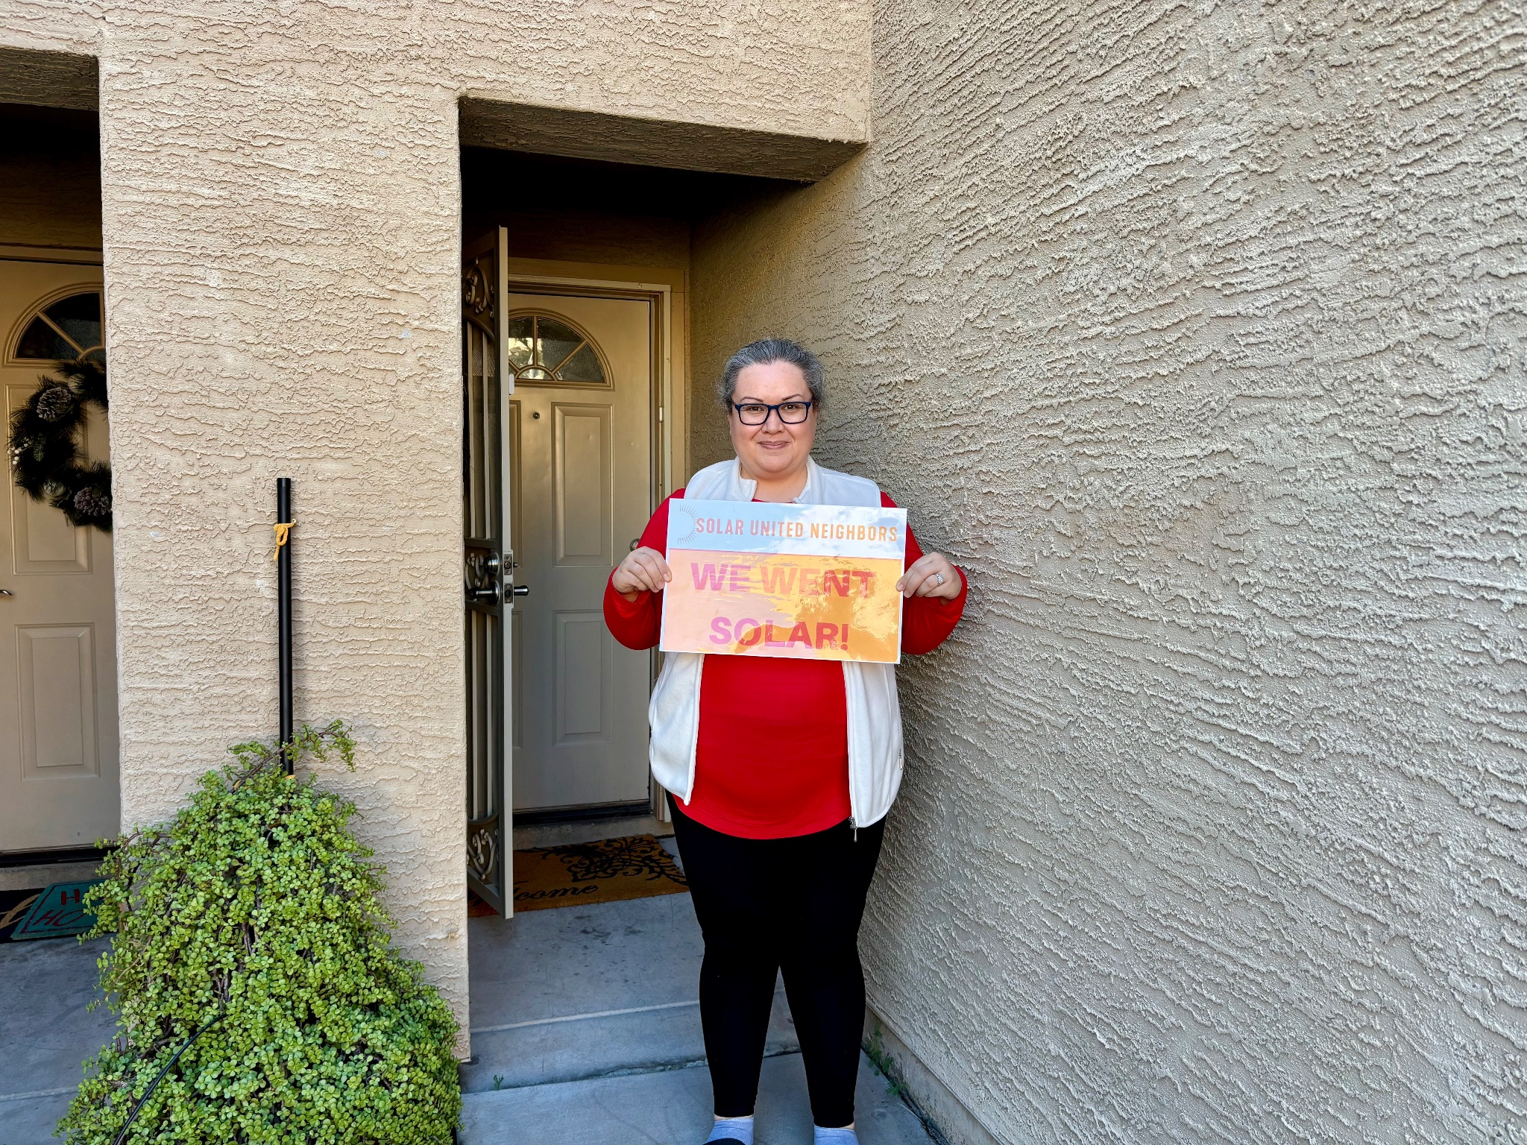

Laura in front of her newly solar-powered home!