Debrief Report
Climate Connections for Buffalo’s East Side Youth project
Omega Mentoring Program and Erie County Department of Environment & Planning

Leadership from Omega Mentoring Program and the Erie County Department of Environment and Planning met on Monday June 12, 2023 for a final project wrap up and debrief. After review and edits to the final report and budget document, the discussion focused on lessons learned and plans for the future.
Lessons Learned
Despite good planning and communication up front, there were several lessons learned:
- The most successful sessions followed the agreed to format, which involved a short talk (10 minutes), and then let the students move around to hands-on stations. Despite extensive planning, a couple of the partners deviated from this format and ended up giving longer lectures, which were difficult for the students as they had already come from a full day of school. In the future, we will use a timer or signage to help speakers manage their time.
- It was enough just to introduce the students to the work going on in the community and the associated opportunities. This introduction built a foundation for a strong relationship, but we did not have capacity to do a lot of the writing we had planned. This is something we will work toward as the relationship grows and strengthens.
- We should have budgeted more money for food and some for transportation too.
Next Steps
Environmental Projects: The students identified a handful of environmental projects they would like to pursue at Johnnie B. Wiley Amateur Athletic Sports Pavilion, where the Omega Mentoring Program meets. These include:
- holding a community repair café with the Tool Library held during the Johnnie B. Wiley Kuleta Pamoja community market held on Saturdays,
- planting a native plant/pollinator garden,
- establishing a bike share program with Reddy Bike through Independent Health,
- planting a community garden,
- and installing a filtered water bottle refilling station.
The County will assist with creating partnerships and finding funding to complete as many of these projects as possible.
Fall Programming: Working with the students during the project’s finale event and the Omega Mentoring Program leadership, it was agreed that the program would continue in the September. The focus of the semester will be tours of businesses, agencies and not-for-profits that are addressing climate action, sustainability and/or environmental justice. Eight to nine tours will be planned from the following selected by the students:
- A Food Forest being planned in JFK Park in the City of Buffalo
- Tifft Nature Preserve – an urban nature preserve built on a brownfield
- Electrician Programs – at community college
- Harmac Medical –a local manufacturer on the East Side of Buffalo that is a leader in sustainability
- Colonel Ward Pumping Station – City of Buffalo drinking water facility
- African American Food Coop – in the process of building a site on the East Side
- Solar array and net-zero building – University at Buffalo
- Wind turbines at Bethlehem Steel* - former steel manufacturing site with wind turbines
- Hydroelectric power plant in Niagara Falls
- Solar carousel at Canalside (Buffalo’s Waterfront)
- Buffalo Recycling Center- South Buffalo
- Veridi Parente – Electric Construction Equipment/Battery Back-Up company on the East Side of Buffalo
- Lead Issues – Erie County Health Department; NYS Attorney General’s Office
Erie County will plan the tours, which will be held every other week starting on September 18, and seek funding for transportation. The Omega Mentoring Program will work with the students on off-weeks to write about each experience.
Conclusion
This grant funding has led to programming that all parties are looking forward to continuing. The students were eager to brainstorm ideas about projects and vote on tours. The students also suggested tours that were not on the suggested list. One of the students is graduating from High School, but has expressed interest in the internships that were presented during the project. County leadership will work to connect him those opportunities that interest him most.

January 9, 2023: Erie County Community Climate Action Plan
Students circulated between different activities to meet County Sustainability Staff and learn about climate action: natural climate solutions and plants, solar powered smoothies, electric vehicle planning exercise, climate myths vs. facts, and a waste reduction game. The County’s draft Community Climate Action Plan is open for comment until June 18 and the students have been requested to comment on the plan and encourage their families and friends to do so. www.erie.gov/climateaction
I learned that there are a lot of different ways you can help save the earth and minimize how much trash you make. – Jaylin

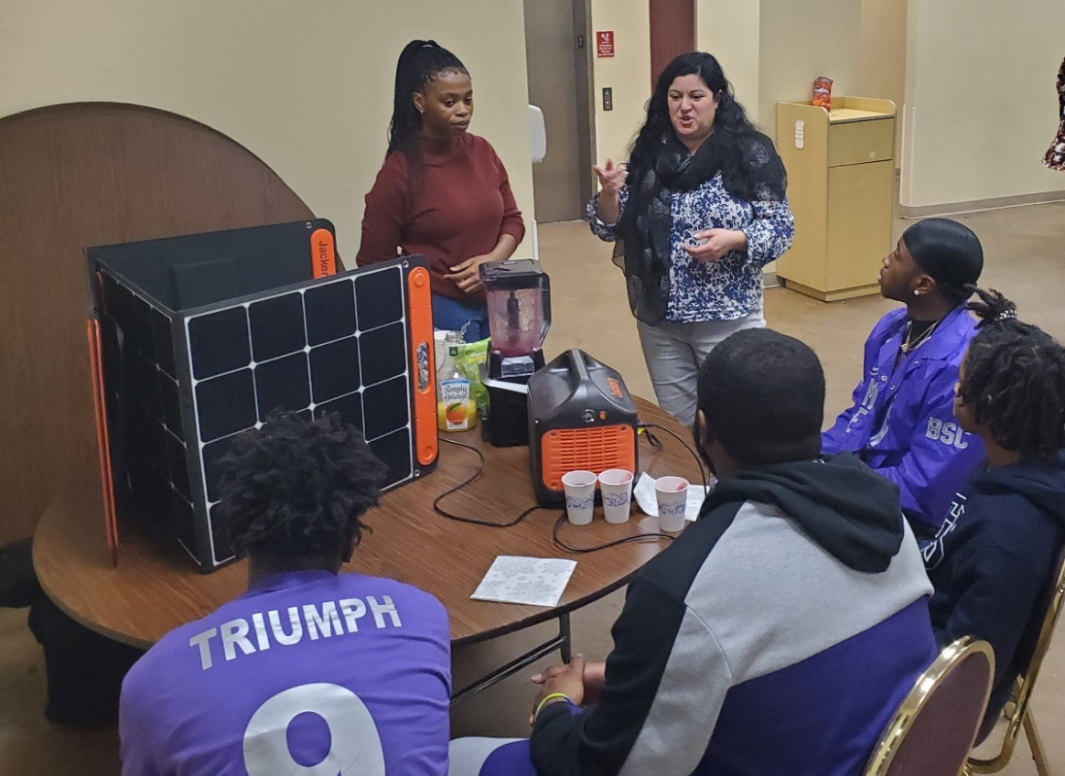
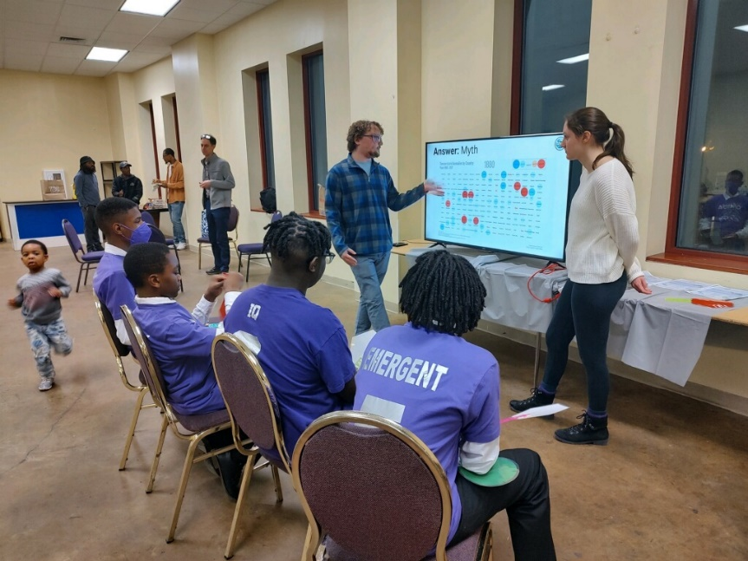

January 23, 2023: Buffalo Sewer Authority
This event included an introduction to water treatment, an Enviroscape Demonstration, and small group discussion about Green Infrastructure Job Training Opportunities. https://raincheckbuffalo.org/ and https://www3.erie.gov/environment/how-can-you-prevent-stormwater-pollution
Something I learned today is that there are many ways to help our community. – Kingston
I learned that in Buffalo climate change manifests itself through water. – Mia
Climate change shows through water and intense storms. – Drevon
Plant infrastructure is used to reduce storm water in sewer system. – Rezen

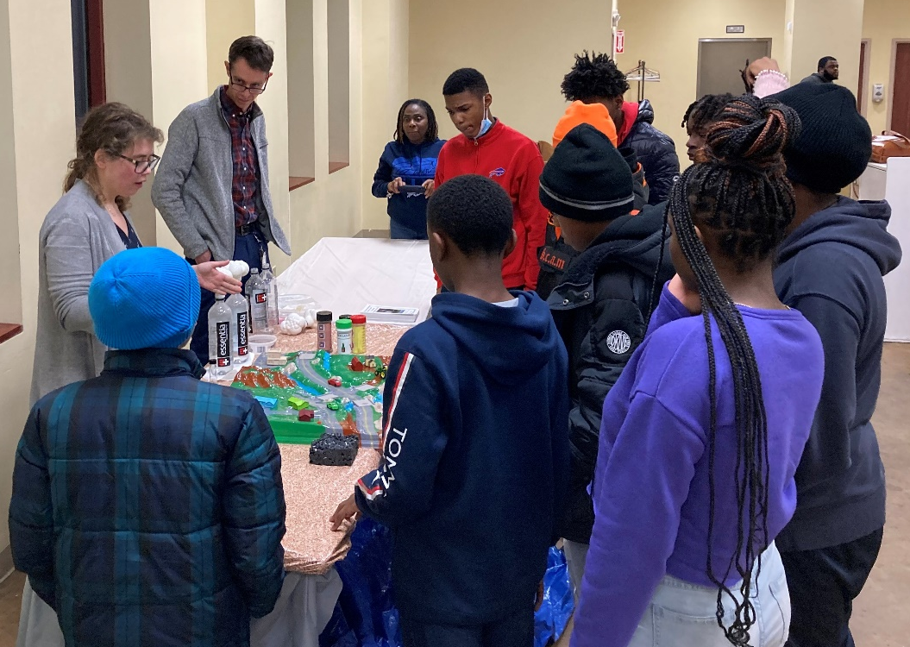

February 6, 2023: WNY Sustainable Business Roundtable
Students met in small groups with professionals from M&T Bank, Rich Products, UB, Borderland Music Festival and Roundtable staff about career paths and internships. www.wnysustainablebusiness.org
I want to explore coding and engineering. These career paths could connect with sustainability in many ways. – Jaylin
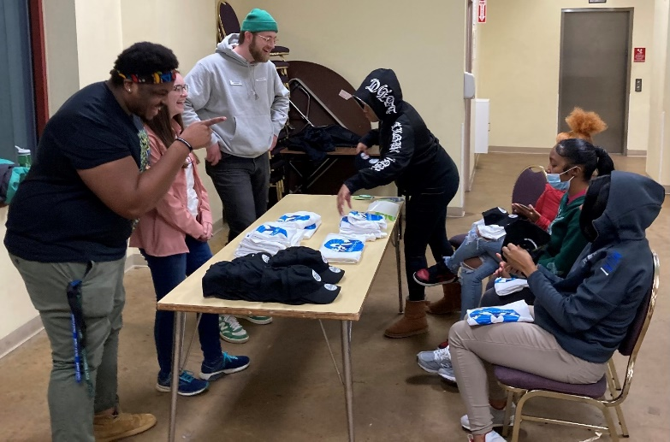
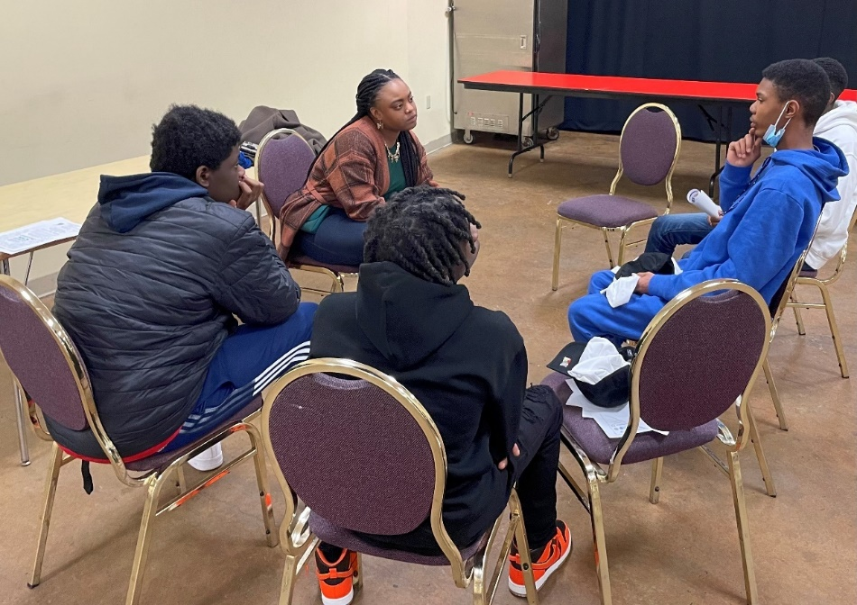

February 20, 2023: The Construction Exchange - Building Trades
A series of hands-on activities included a blueprint scavenger hunt, plumbing projects, construction demonstration, cement truck, as well as information on electrical training programs. https://careers.conexbuff.com/career-explorer/ and https://conexbuff.com/education/
I learned that Plumbing is cool. I made the strongest and tallest building. Maybe I may start building things. – Mia

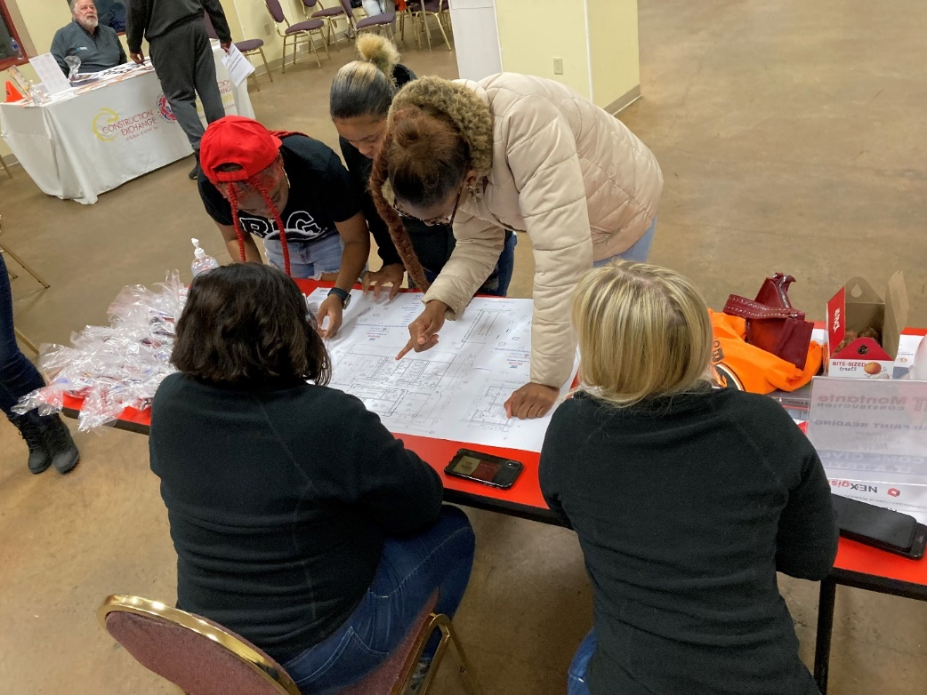
March 6, 2023: City of Buffalo – Citizen Engagement and Environmental Design
Crime Prevention through Environmental Design (CPTED). The City outlined their citizen engagement program and took the students through a planning exercise.
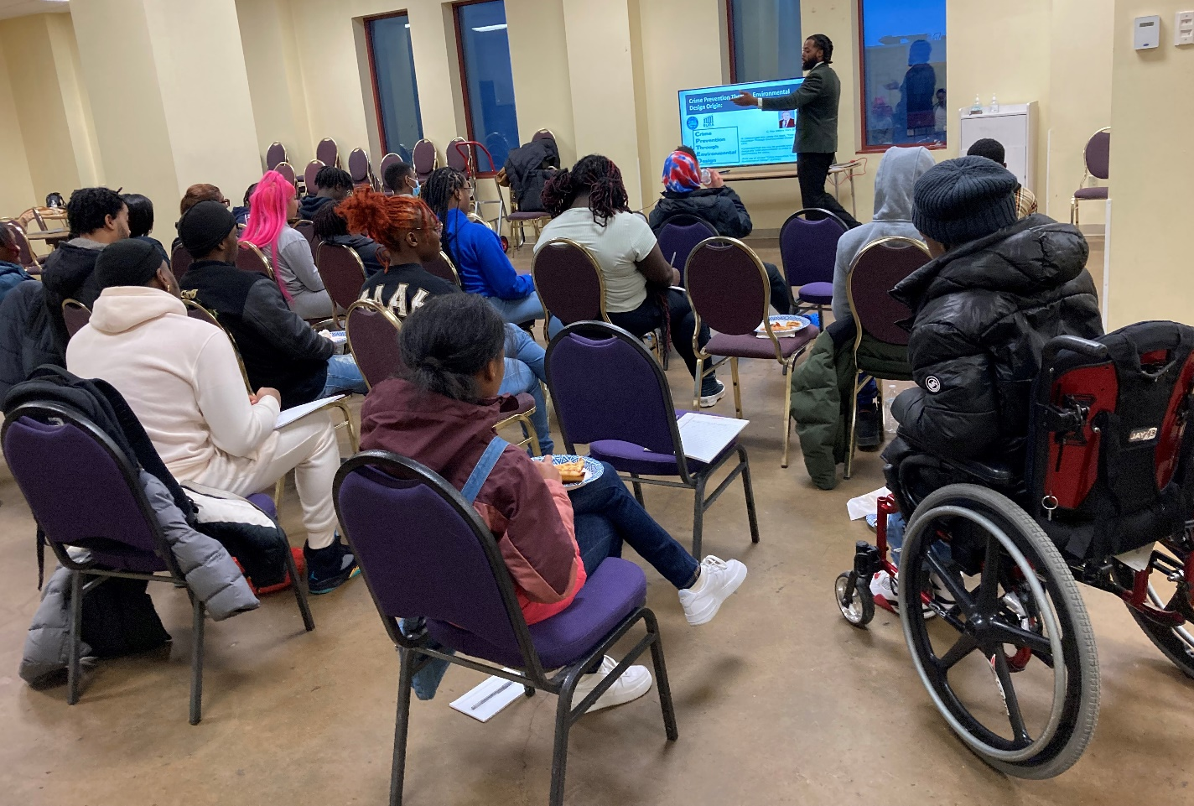

March 20, 2023: Natural Climate Solutions: Beekeeping, Compost & Native Plants
Pelion Garden, located across from City Honors High School, not far from Johnnie B. Wiley where the Omega Mentoring Program meets, presented information about beekeeping. Pelion has many programs including beekeeping for high school students https://www.peliongarden.org/. Local native plant and composting experts, Ken Parker and Ignacio Villa, had hands-on activities as well.
You can water plants from the bottom holes. – Drevon
I learned about the amazing power of compost and the growing process. Will be trying to compost this year! – Abijah
Today I learned about the many wonders of bees and soil. – Emani

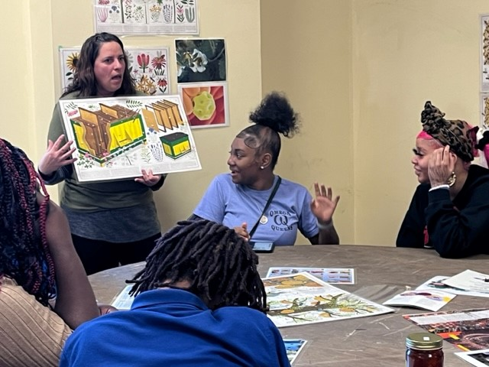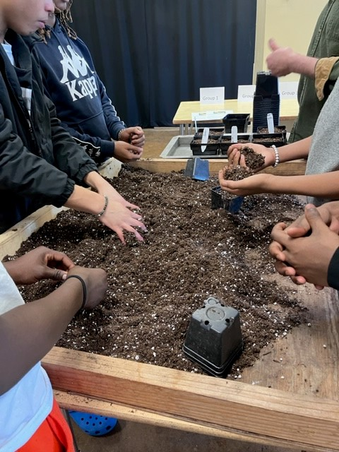

April 17, 2023: PUSH Buffalo
People United for Sustainable Housing (PUSH) Buffalo presented on sustainable housing and youth engagement https://www.pushbuffalo.org/mission/ and youth programs at Grant Street Neighborhood Center https://www.pushbuffalo.org/gsnc/. This had been planned as an on-site tour, but due to a driving rain storm and cold temperatures was moved indoors at Johnnie B. Wiley.

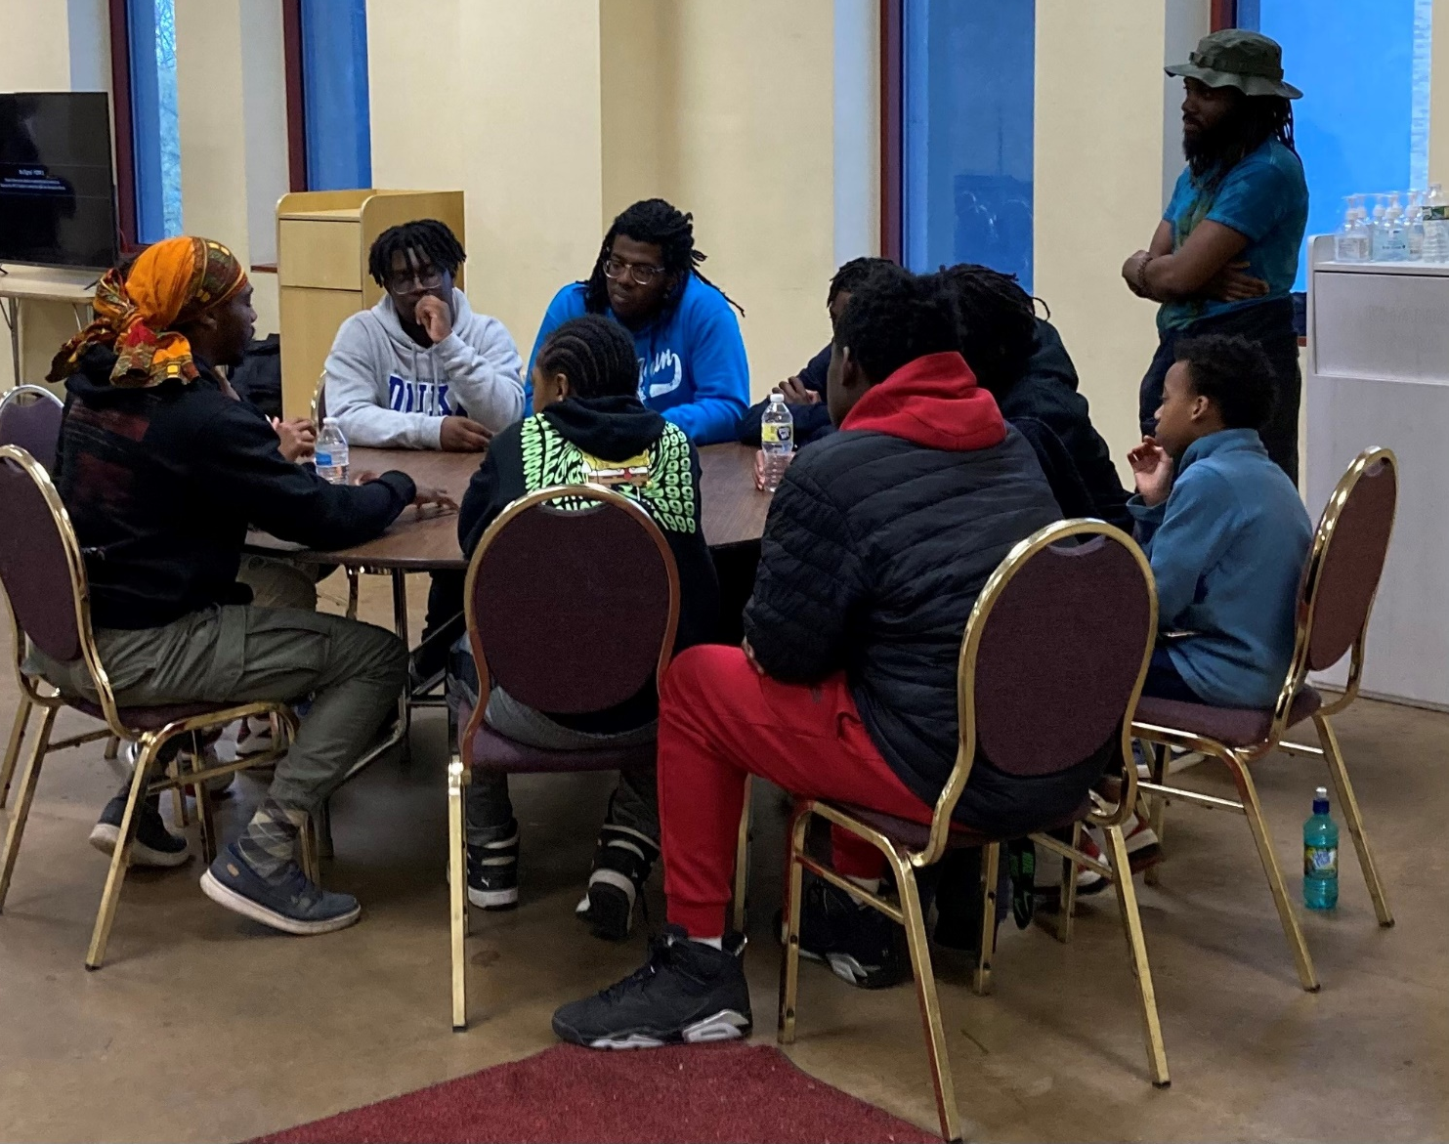

May 1, 2023: Massachusetts Avenue Project Tour
Massachusetts Avenue Project (MAP) embodies many of the sustainability actions that have been explored during the previous sessions but stressed food access and youth leadership. Activities were led by MAP’s student leaders. https://www.mass-ave.org/
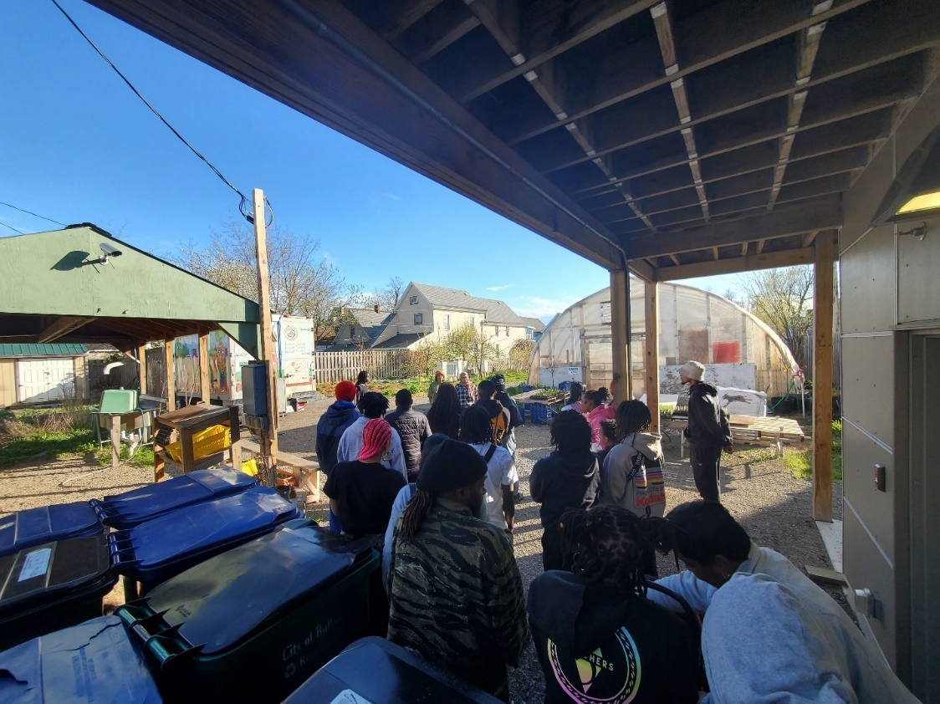

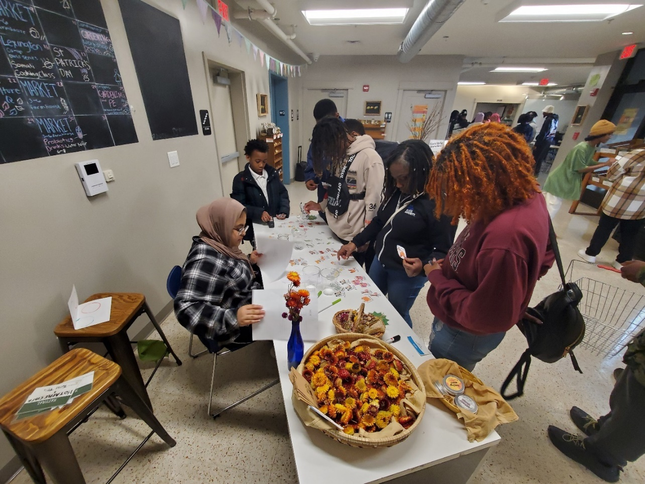

May 15, 2023: Tool Library
The Tool Library shared information about reuse and the sharing economy. After a short presentation, the Tool Library ran a Repair Café where fixers repaired items brought in by students and Near Peers. The students, Near Peers, and leadership were interested in joining their library where for $30 per year you can check out tools at the tool library (including power washers and lawn mowers). https://thetoollibrary.org/

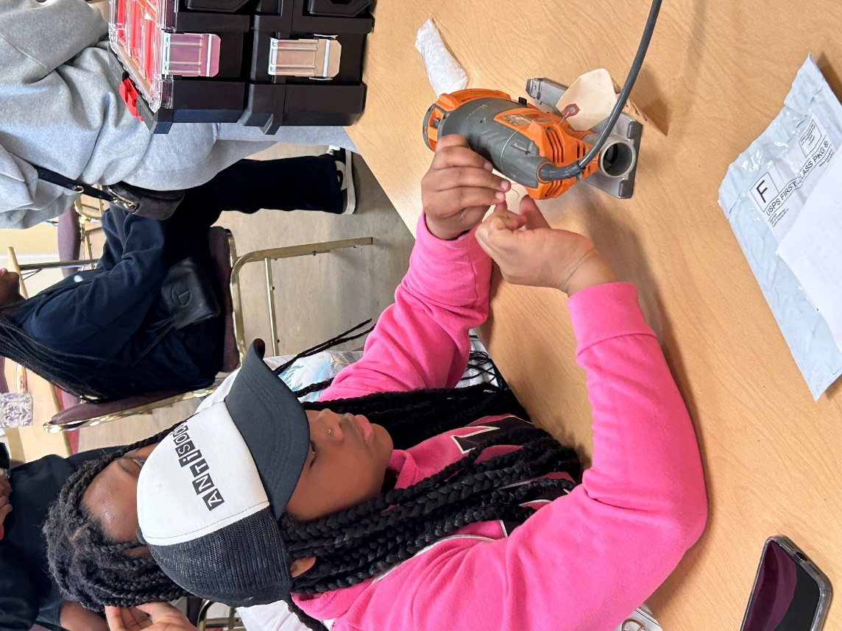

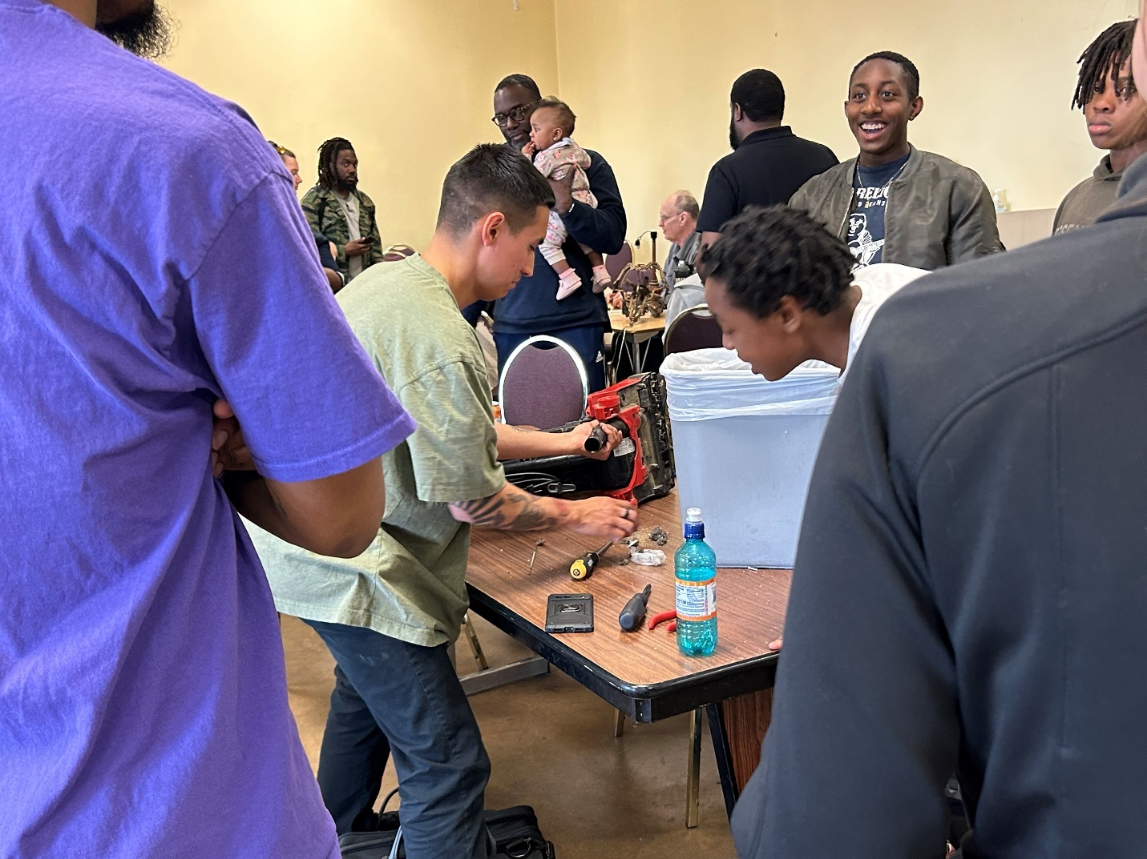

June 5, 2023: Project Finale
The project finale as planned by the Omega Mentoring Project and Erie County will include several elements:
- Presentation of student/group projects to share what they have learned
- Brainstorming
  - environmental projects to be implemented and
  - next steps for the program
- Celebration
Families and environmental partners will be invited to join in the celebration. Press releases and media advisories will be developed by the County.

