Chugach Beneficial Electrification and Energy Star Incentive Program in Anchorage, AL

Chart 1.5 Chart of BEES Incentives
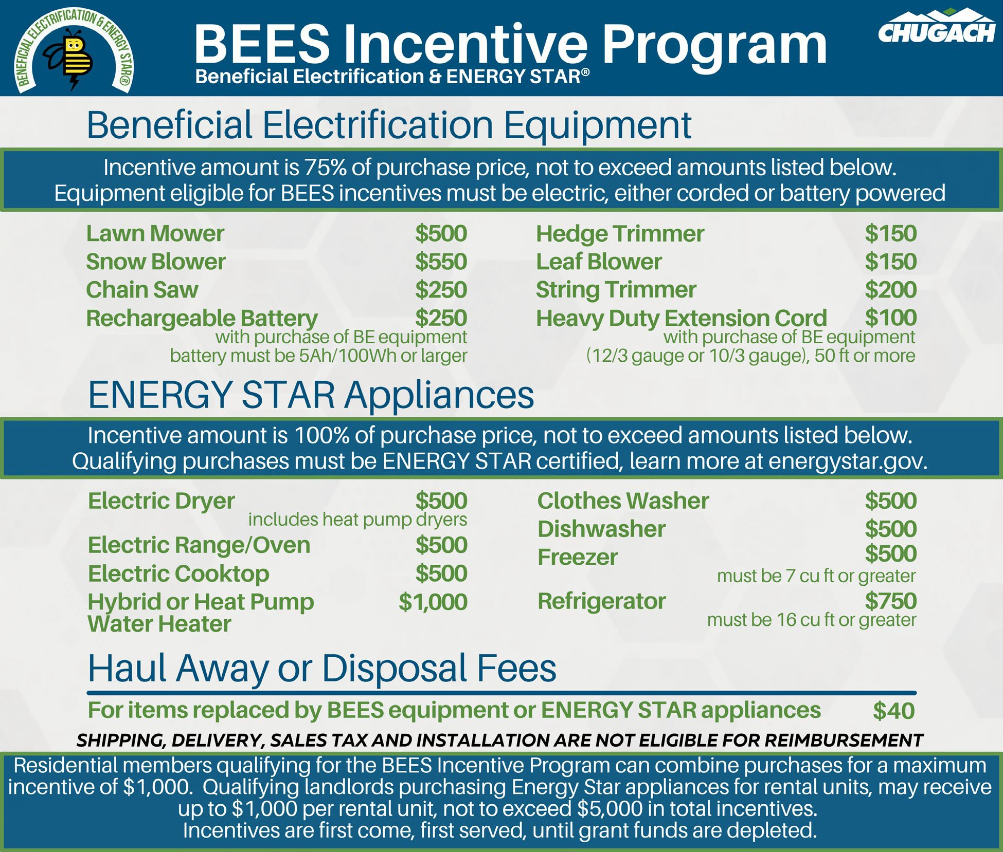

Table 1.5 Applications Received and Approved

Applications | Landlord | Residential
Received | 16 | 116
Approved | 11 | 104

Table 2.6 ENERGY STAR® Appliances Purchased

ENERGY STAR® Appliances | Landlord Purchases | Residential Purchases
Electric Dryer | 2 | 14
Clothes Washer | 3 | 17
Electric Range/Oven* | 1 | 8
Electric Cooktop | 0 | 0
Hybrid or Heat Pump Water Heater | 0 | 0
Dishwasher | 2 | 12
Freezer | 1 | 4
Refrigerator | 10 | 18
Haul Away/Disposal | 1 | 14
*not required to be ENERGY STAR® certified
Total Appliances Purchased | 20 | 87

Table 3.6 Beneficial Electrification Equipment Purchased

Beneficial Electrification  Equipment | Residential  Purchases
Lawn Mower | 26
Snow Blower | 6
Chain Saw | 9
Rechargeable Battery | 4
Hedge Trimmer | 1
Leaf Blower | 17
String Trimmer | 22
Heavy Duty Extension Cord | 0
Total BE Equipment Purchased 85

